Case Study: Flipkart Web Application Clone
1. Introduction
Flipkart is one of the largest e-commerce platforms in India used for buying products like electronics, fashion, home appliances, and more. It provides users with features like product search, filters, product listings, and secure checkout.
The purpose of this project is to develop a Flipkart-like product listing webpage using HTML, CSS, and JavaScript to understand modern e-commerce UI design, layout structure, and user interaction.

2. Objective of the Project
The main objectives of this project are:
• To study the user interface of Flipkart
• To create a responsive product listing page
• To design a filter sidebar similar to e-commerce websites
• To implement product cards with pricing and details
• To practice HTML, CSS, and JavaScript integration

3. Problem Statement
E-commerce websites need to display large numbers of products efficiently while maintaining a clean and user-friendly interface.
Traditional layouts may not provide proper filtering and structured display, making it difficult for users to browse products.
Flipkart solves this by using:
- Structured product cards
- Sidebar filters
- Sorting options
The challenge of this project is to recreate a similar product listing interface using basic web technologies.

4. Technologies Used
Technology | Purpose
HTML | Structure of the webpage
CSS | Styling and layout design
JavaScript | Interactivity and dynamic behavior
Web APIs | Placeholder images for demo products

5. System Architecture
The system consists of three main layers:
1. Frontend Layer
This includes user interface elements such as:
• Navigation bar
• Search bar
• Filter sidebar
• Product listing cards
These components are created using HTML and CSS.

2. Interaction Layer
JavaScript handles user interactions such as:
• Clicking filters (brand, processor, etc.)
• Highlighting selected options
• Sorting and dynamic UI updates

3. Content Layer
Products are displayed in structured cards including:
• Product image
• Title
• Specifications
• Price and discount

6. Output and Clone Image
Figure 1: Original Flipkart webpage
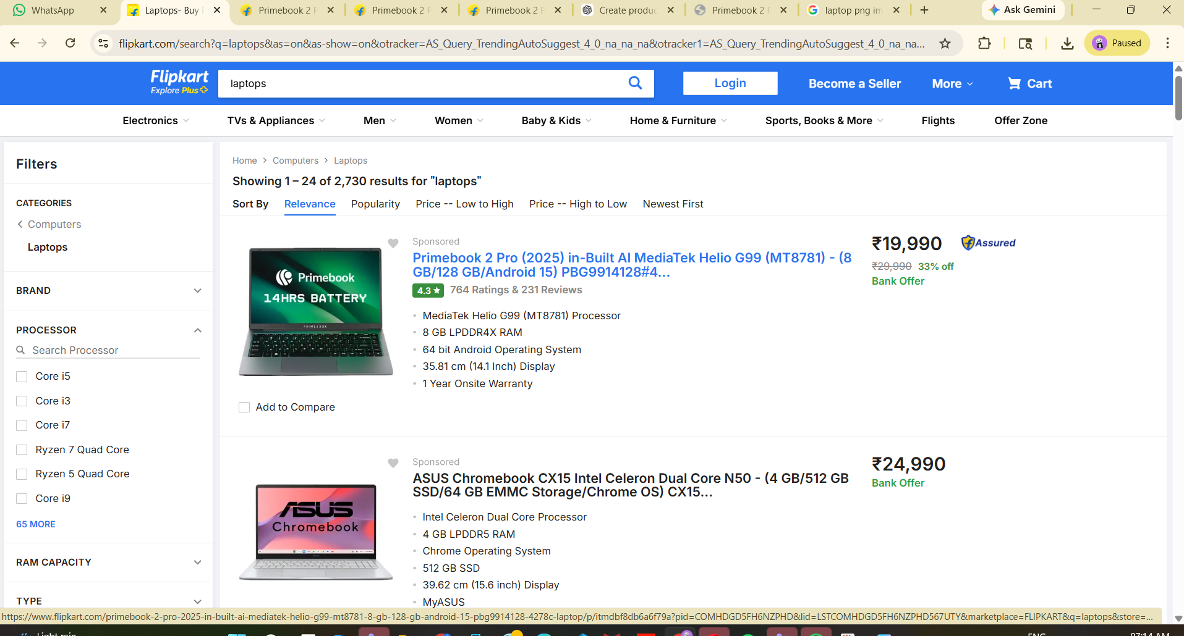
Figure 2: Clone webpage created using HTML & CSS
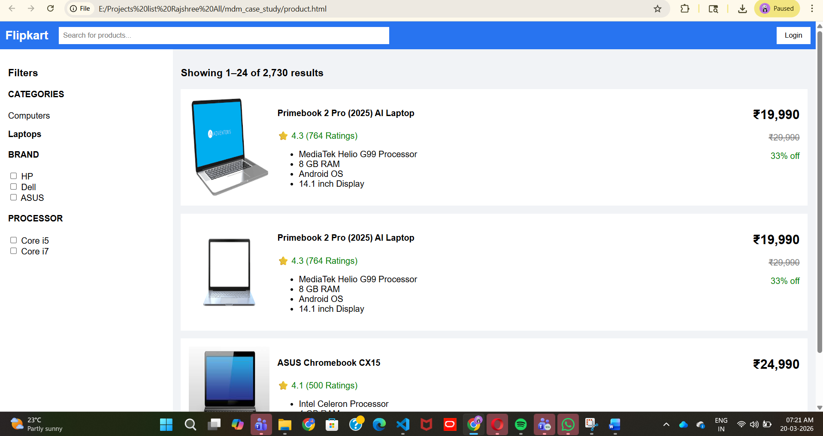

7. Implementation
The application is implemented in three main parts:
HTML Structure
HTML defines the webpage layout including:
• Header (logo, search bar, login button)
• Sidebar filters
• Product container
• Individual product cards

CSS Styling
CSS is used for:
• Layout design (flexbox/grid)
• Colors and fonts
• Spacing and alignment
• Responsive design

JavaScript Functionality
JavaScript is used for:
• Filter selection effects
• Dynamic UI behavior
• Basic sorting functionality

8. Advantages
• Clean and user-friendly interface
• Efficient product browsing experience
• Responsive design for different devices
• Easy to extend with backend features

9. Limitations
• No backend functionality
• No real product database
• Filters are static (not functional with real data)
• No login or cart system

10. Future Improvements
In future, the following features can be added:
• User authentication (Login/Register)
• Add to cart and checkout system
• Payment integration (like Razorpay for your project)
• Dynamic product loading from database
• Advanced filtering and search
• Backend using PHP / Node.js
• Database integration using MySQL

11. Conclusion
This project successfully demonstrates how an e-commerce interface similar to Flipkart can be built using HTML, CSS, and JavaScript.
It helps in understanding:
• UI/UX design of e-commerce platforms
• Product listing structure
• Filtering and layout systems

